Project Architecture
Name: Employee Management
Technologies: Front-end (Angular) and Back-end (Java SpringBoot)
Date: September 17, 2022
Author: Gaurav Sharma

Full Stack Development

- Frontend
Technologies used
    - Angular 14.2.0
    - Typescript 4.7.2
    - HTML5
    - CSS3
- Backend
Technologies used
    - Java 11
    - SpringBoot 2.7.3
    - PostgreSQL 14.5

Application Modules

- Login and Sign up
  - This module will allow authentication and registration into the application
  - Credentials will be used by admins to access application
- Dashboard
  - This module will highlight primary features of the application and allow logged in user to access them directly
- Employee
  - This module will allow logged in user to add employees and view their details
- Payroll
  - This module will allow logged in user to generate payroll for the employee and view the payroll history
Data Dictionary

1. User table
Sr. No. | Column Name | Data Type | Size
1 | user_id(PK) | Numeric | 3
2 | user_name | varchar | 20
3 | email_id | varchar | 30
4 | phone_number | Numeric | 10
5 | Password | Varchar | 15
6 | date_added | Date/Time | -

2. Employee table
Sr. No. | Column Name | Data Type | Size
1 | employee_id(PK) | Numeric | 3
2 | name | Varchar | 20
3 | address | Varchar | 50
4 | phone_number | Numeric | 10
5 | designation | varchar | 15
6 | daily_wage | Numeric | 3
7 | doj | Date | -
8 | last_day_of_working | Date | -
9 | date_added | Date/Time | -

3. Payroll table
Sr. No. | Column Name | Data Type | Size
1 | payroll_id(PK) | Numeric | 3
2 | employee_id(FK) | Numeric | 3
3 | payroll_month | Numeric | 2
4 | attendance | Numeric | 2
5 | daily_wage | Numeric | 3
6 | generated_salary | Numeric | 5
7 | deductions | Numeric | 5
8 | net_pay | Numeric | 5
9 | payment_mode | Varchar | 6
10 | date_added | Date/Time | -

Application Design
URL: https://www.figma.com/file/Uj1Z6NxHjCIc3wPhZZXyOo/Employee-Management?node-id=0%3A1
Credentials: Google Login

Login page
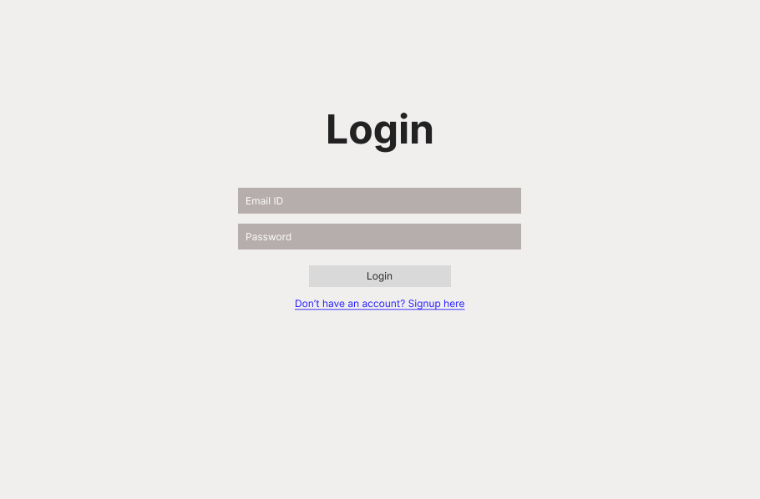
Signup page
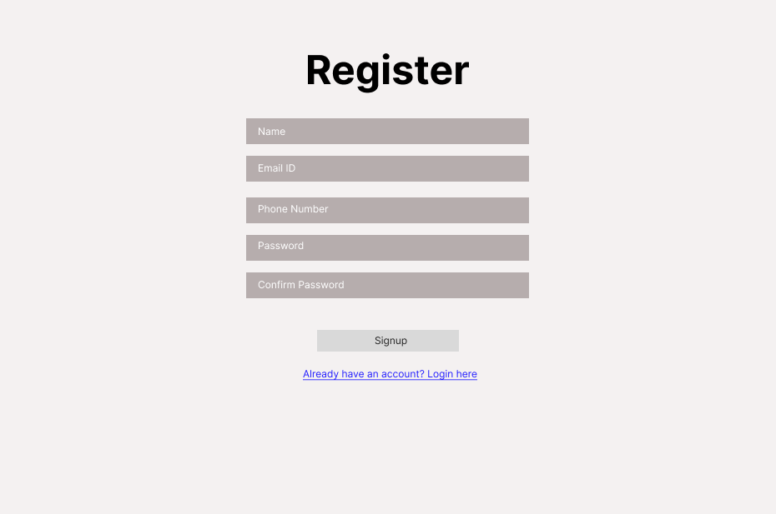
Dashboard

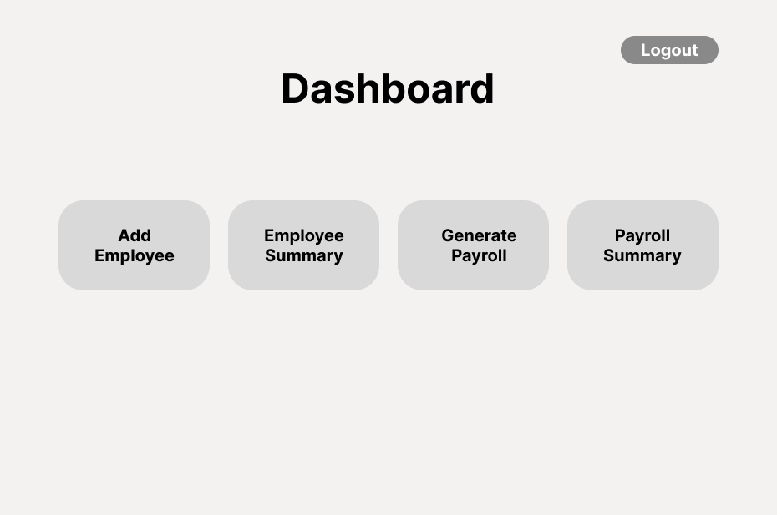
Add Employee
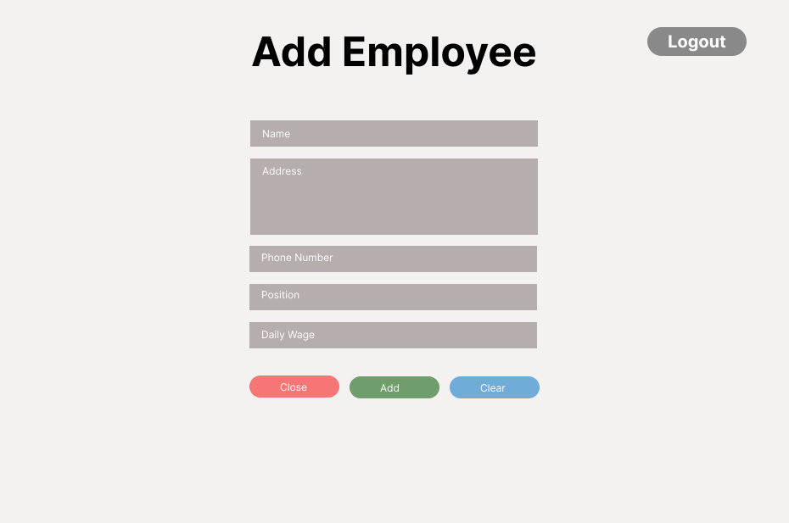

Employee Summary

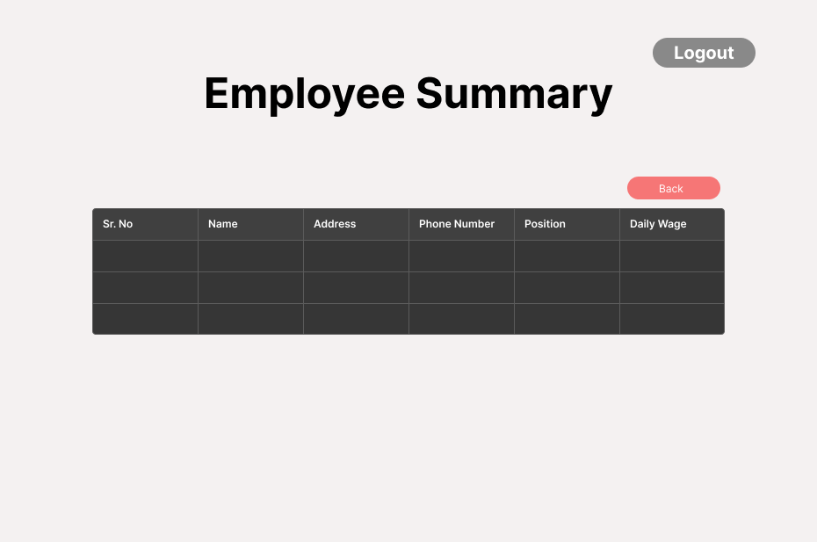
Generate Payroll

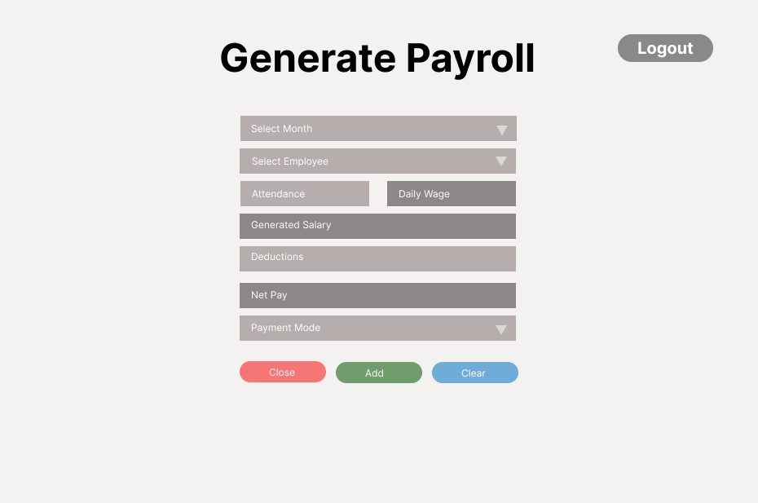

Payroll Summary
